Cultural Collaboration at a Distance
Francisco Cano, Alexandra May, Ryan McKenzie, Andrew Novak, Kristin Scheivert,
and Jessica Siders
EDUC 663 - Liberty University

Needs Identification:
Teachers need more resources and learning opportunities for their students to discover diverse cultures through increasing reading, writing, digital citizenship, and social and emotional skills.
Goal Statement:
Incorporating PenPal Schools and the Virginia State Standards of Technology for 9-12.15, Technology Communication Tools, will enable teachers of on-line programs to have access to a collaborative learning environments in which the learners will target the standard: communicate effectively with others (e.g., peers, teachers, experts) in collaborative learning situations to increase reading, writing, digital citizenship, and social and emotional skills.
Task Analysis: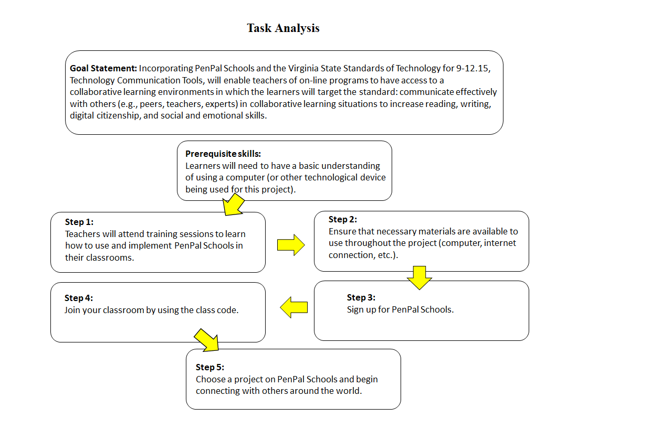

Context and Learner Analysis:
Upon researching, Pappas (2015) describes that using the Dick and Carey Model of instructional design analyzes the target audience and the context in which they will be learning using the third step of the process. Traits analyzed are directly related to the performance objectives. This leads to the use of PenPal Schools as a tool for teachers to introduce and track student progress in cultural interaction.
Based on the work by Wang and Lui (2019), many societies engage in social media, which is moderated by each culture’s view of social media and privacy concerns. PenPal Schools are accessible through web-based browsers and through forms of technology such as mobile devices and tablets. Through the use of social media, it is important that teachers are aware that cultural differences will affect how and why other cultures would choose to participate in cultural interactions and that cultural interactions may lead to controversial topics. This requires constant monitoring to maintain that students remain on task and objective oriented.
Learner Specific (Table 1):
General Characteristics | Adult Educators in Virginia who are currently in the field teaching grades 9-12.
Prior Knowledge/Skill/Ability | Learners will have at least some knowledge of technology and learning techniques within the realm of student communication through computers and teaching.
Is the Topic Interesting? | Learners will find the PenPal School program nostalgic and may be intrigued by the incorporation of Cultural Diversity and Etiquette.
Attitudes Toward Content | Content will satisfy Virginia State Standards of Learning, Computer Technology for 9-12.15, Technology Communication Tools. Learners may be disinterested in satisfying the goal in this way or maybe dissatisfied with SOL’s in general.
Attitudes Toward Delivery System | The attitudes will depend on the learner themselves and their openness to new ideas incorporating user-friendly software.
General Learning Preferences | Active, hands-on, experience-based learning in a communal environment. Initially, it would be the vendor to the teachers and then the teachers doing the program.  Group learning where the teacher takes the role of facilitator suits adult learners best. Adult learners need to understand why the information is important to them.  Self-paced, online module to interest teachers into creating a more culturally diverse community within their classrooms.  The training will be in a virtual classroom using Google Slides and PenPal School Webpage. This will allow us to theoretically answer any questions that may arise during the training.
Attitudes Toward Training Organization | The learners will hopefully appreciate the online creators of the module because they incorporated an easy to manipulate webpage that is also self-paced for all who use.
Important Group Characteristics | The module is designed as a Pilot Program to help schools become more culturally diverse and responsive.  Due to it being a pilot program, the learner’s responses will be used to modify and create a more beneficial final presentation.

Instructional Objectives –
Goal- Incorporate PenPals
- The learner will attend an online training session that provides them with the necessary information for the program.
- The learner will be an active participant in the training session by communicating their ideas.
- The learner will provide constructive feedback on each portion by completing an overall survey of the training sessions.
Step 1- Training Session
- To complete the requirements, the learner will have met the needs of all prerequisites
- Using a district-issued device, the learner will be an active participant in the training sessions to ensure comprehension of the topic.
- The learner will successfully sign into the district website to access the training module.
Step 2- Needed Materials
- For the website to work appropriately, the learner will need access to low-speed, consistent, internet.
- Using a fully functioning district-issued device, the learner will be able to successfully access PenPals Schools.
- The learner will collect from each participant a parent/guardian permission form.
Step 3- Learner Login
- The learner will be able to successfully register him/herself for a PenPal Schools account.
- Using the necessary materials, the learner will be able to successfully create their own PenPal Schools account.
- The learner will be able to correctly input the login information on the PenPals Schools website.
Step 4- Participant Sign up
- Within a week after the training session, the learners will be able to successfully enroll students using PenPal Schools.
- Using a checklist, the learner will be able to identify which enrolled individuals can or can not login.
- The learner will be able to assist those who are unable to correctly sign up for PenPal Schools.
Step 5- Choose Project
- The learner will be able to successfully choose a project that fits the participant’s academic needs (i.e. reading level).
- Using cross-curricular connections, the learner will have students discuss a specific topic with their PenPal.
- The learner will choose a project for their students that satisfies Virginia State Standards of Technology for 9-12.15
Instructional Strategy and Assessments
In order to fulfill the pretest requirement, the learner will read through the instructional objectives, accept the module terms, and agree to complete the posttest by clicking “Next” to state they are ready to begin. We will gain student motivation through response questions presented throughout the presentation. The student will independently navigate their way through the module. When completing the module the learner will have two browsers side by side that allow them to go through the proper steps in order for them to complete the instructional objectives. Each part of the module will be completed individually until the final assessment. By the end of the module, the learner will reiterate to another participant how to enroll, sign up students, and present PenPal Schools information to ensure mastery of content.
Presentation will include a step-by-step instruction document for optional use of learners and students (website, sign in, how to find your specific project), along with Login/Password help. After successful login of participants, the learner will be asked to play a student-teacher role to both demonstrate their own mastery, and to help understand the student’s perception of the material, serving as practice for the PenPal instruction of the student’s in participant’s own classroom.

Table 2:
Module # | Title | Objectives | Assessments | Activities | Instructional Content/ Materials | Student Participation | Media Development and Implementation | Time Allotments/ Notes
1 | Training Session | To complete the requirements, the learner will have met the needs of all prerequisites. | Pretest: | Reading | Module  District-issued device  Internet access | Read objectives  Accept the modulele terms  Agree to complete the posttest | District-issued device  District training website | 2-5 minutes
 |  | Using a district-issued device, the learner will be an active participant in the training sessions to ensure comprehension of the topic. | Question- Response | Question- response prompts | Module  District-issued device  Internet access | Answer questions on specific slides of the module | District-issued device  District training website | 10-15 minutes
 |  | The learner will successfully sign into the district website to access the training module. | Checklist | District training website login | Module  District-issued device  Internet access | Sign into district training website | District-issued device  District training website | 1-2 minutes
2 | Needed Materials | For the website to work appropriately, the learner will need access to low-speed, consistent, internet. | Open Google Slides  Or locate website url | Ensure Internet is accessible and network properly working | Website/ connection requirements provided in Google Slides | Locate URL and click or type into web browser | District-issued Device  District website  PenPal Schools website | 1-5 minutes
 |  | Using a fully functioning district-issued device, the learner will be able to successfully access PenPal Schools. | Google Slides Slides | Go to PenPal Schools Website via provided link | Google Slides step-by-step to access | Student will contact moderator if unsuccessful | District-issued device | 1-5 minutes
 |  | The learner will collect from each participant a parent/guardian permission form. | Checklist | Check for names of classroom students | Explanation of why legality is important. | Turn in Permission slips to assigned school personnel | District-issued device | Will have a deadline of 1 week prior to the start of Individual classroom student participation.
3 | Learner Login | The learner will be able to successfully register him/herself for a PenPal Schools account. | Checklist, proper registration account | Viewing video demonstrations, reading instructional text, completing checks on learning, and following walk-through | Video demonstration, text instruction presented through Google Slides, and active walk-through | Students do not register for PenPals School accounts | Video demonstrations, check on learning quizzes, and instructional text through Google Slides presentation | 10-15 minutes
 |  | To complete the requirements, the learner will attend each training session. | Training session acknowledgement and/or check on learning quiz | Active participation in training sessions, acknowledgements of each training session | Google Slides requires active participation through checks on learning, active walk-through, and acknowledgement through next button | Students will be present during course instruction once learner has completed and demonstrated competence | LMS tracking if available, signing an attendance roster as secondary method of tracking | 5-10 minutes
 |  | The learner will be able to correctly input the login information on the PenPals Schools website. | Checklist, proper login to access account for setup and maintenance | Completion of actively following walk-through process | Video demonstration, text instruction presented through Google Slides, and active walk-through | Students will be able to login once learner has successfully logged in and created course in PenPals Schools | Video demonstrations, check on learning quizzes, and instructional text through Google Slides presentation | 2-5 Minutes
4 | Participant Sign up | The learner will be able to successfully register him/herself for a PenPal Schools account. | Google Slides | Sign Up  Confirmation | District Issued Device  Internet Access | Follow sign up steps in PenPal Schools.  Receive confirmation of enrollment from PenPal Schools. | PenPal Schools Website | 5-10 minutes
 |  | The learner will be able to assist those who are unable to correctly sign up for PenPal Schools. | Google Slides | Communicate with participants | District Issued Device  Internet Access  PenPals Access Code | Communicate with participants who are unable to sign up for PenPal Schools | PenPal Schools Website. | 5-10 minutes
5 | Choose Project | The learner will be able to successfully choose a project that fits the participant’s academic needs (i.e. reading level). | Use the Standards of Learning and performance guidelines for the child’s level | Select a topic based on 3 topics based on what the student is learning | District/School issued device  Internet access  PenPal Schools access code | Choosing an appropriate and desired project from PenPal Schools. | PenPal Schools website | 30 minutes - 1hour
 |  | Using cross-curricular connections, the learner will have students discuss a specific topic with their PenPal. | Current Curriculum being taught | Make multi-curricular connections between the state curriculum and PenPal Schools. | District issued device  Internet access  PenPal Schools access code | Discussion with a PenPal. | PenPal Schools website | 30 minutes - 1hour
 |  | The learner will choose a project for their students that satisfies Virginia State Standards of Technology for 9-12.15 | VA State Stds of Technology 9-12.15 and 8VAC20-25-30 | Choose appropriate projects that pair with the Virginia State Standards of Technology for 9-12.15. | District issued device  Internet access  PenPal Schools access code | Choice of project based on Virginia State Standards of Technology for 9-12.15. | PenPal Schools website. | 30 minutes - 1hour
(A. Szapkiw, 2020)
Follow-Through/Summary
In summary, using the instructional objectives, storyboard design, and selected assessments the learner will be able to successfully complete all aspects of implementing PenPal Schools into their classroom. Through individual learning, the learner will also be able to teach others how to implement and appropriately use PenPal Schools.
Media Selection
All Group 1 members will take part in creating a Google Slides presentation that includes instructional videos that also reference PenPal Schools. PenPal Schools may be contacted to receive written permission to use promotional and instructional videos. The presentation will align with the prerequisites, instructional objectives, and the completion assessment. The skills necessary will have been developed through incorporating technology into the 21st century, using connected multimedia devices, such as a laptop with internet capabilities. Google Slides has been selected as the media of choice, due to it being easy to acquire anywhere there is Internet access (EdTech Google for Educators, 2020). Google Slides requires an internet connection and a web browser. No special software or plug-ins are necessary for the presentation. Joe Troyen, (2020) a PenPal Schools support team member, recommended that Google Chrome is selected as the web browser as it interfaces seamlessly with Google Slides and PenPal Schools. PenPal Schools provide individuals with low bandwidth opportunities a rich cultural experience.

References

EdTech Google for Educators. (2020). Create Presentations with Google Slides. Retrieved from https://sites.google.com/a/bvsd.org/google-for-bvsd-educators/presentations
HRDI, 2020, Learner Characteristics and Instructional Design; retrieved from:
https://hrdevelopmentinfo.com/learner-characteristics-and-instructional-design/
Pappas, C. (2015). 9 Steps To Apply The Dick and Carey Model In eLearning. Retrieved from https://elearningindustry.com/9-steps-to-apply-the-dick-and-carey-model-in-elearning
Troyen, J. (2020). Technical Requirements. Retrieved from https://support.penpalschools.com/en/articles/2142449-technical-requirements
Virginia Department of Education. (2020). Computer Technology. Retrieved from http://www.doe.virginia.gov/testing/sol/standards_docs/computer_technology/index.shtml
Wang, X. & Liu, Z. (2019). Online Engagement in Social Media: A Cross-Cultural Comparison. Computers in Human Behavior, 97, pp. 137-150. doi:https://doi.org/10.1016/j.chb.2019. 03.014

